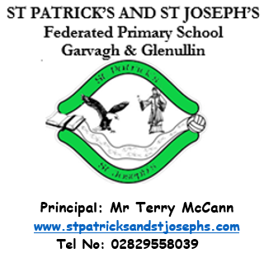
October 2023

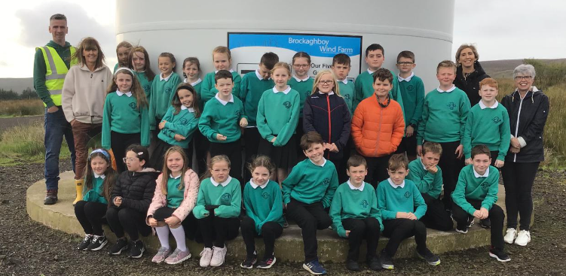
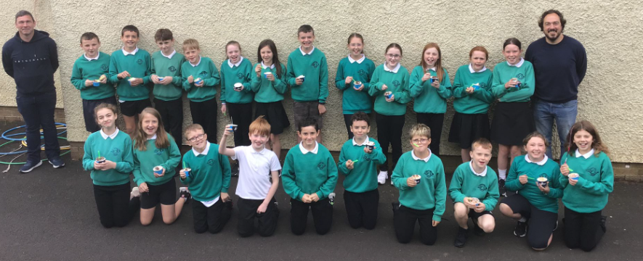
The P6 and P7 pupils had a very informative morning at Brockaghboy Windfarm!.
In addition, an ice cream van provided lovely ice cream for all the children on both the Glenullin site and the Tirkeeran site.
Huge thanks to Conor and Ramón and we look forward to further projects with them in the future.
Drop Off and Collection of Children  Thank you to all parents for making our morning drop off such a success. Please note;  - Both sites are open from 8.30am – children should not be dropped off before 8.30am  - Please reverse cars into car parking bays at both sites  - Inter-site transport is available from Tirkeeran to Glenullin at 8.30am and from Glenullin Chapel car park to Tirkeeran at 8.45am  Saint Vincent de Paul Society  As part of our Hallowe’en Dress Up day on Friday 27 October, we are asking each child to make a voluntary donation of £1 for the St Vincent de Paul Society.  In December we will have our Christmas Jumper Day when children can bring another £1.  Please note that these donations are voluntary, and parents should not feel under pressure to make the donation.  The local SVP are there to provide help to anyone in our parish who is struggling. If you need their help, then please call: 07563595868. |  |  | Parent Meetings  Parent meetings will be held on the afternoons of Monday 23rd, Tuesday 24th, Wednesday 25th and Thursday 26th October. Meetings will take place in the hall at the top site. Times have been sent via Dojo and meetings will last 10 minutes.  P5 Assembly  P5 will perform their assembly for their parents on Thursday 26 October. This is a great opportunity for our wonderful P5 children to showcase their talents. We would ask that parents use the hand sanitisers on the way in.  Attendance  Pupils who have any sickness should remain at home until well enough to return to school.  Use of Children’s images – a reminder  The school has a number of parents who have not given permission for their child’s image to be used or reproduced by members of the public.
Song for the Month |  |  | The song for the month of October can be accessed via the you tube link below.  https://www.youtube.com/watch?v=0CKMaRwicSg
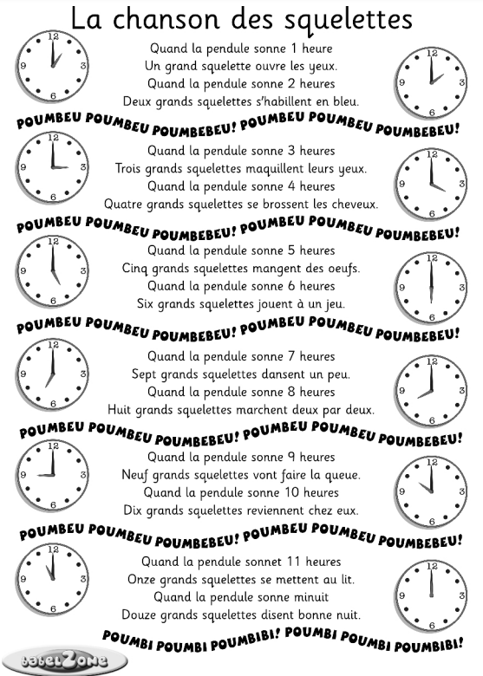
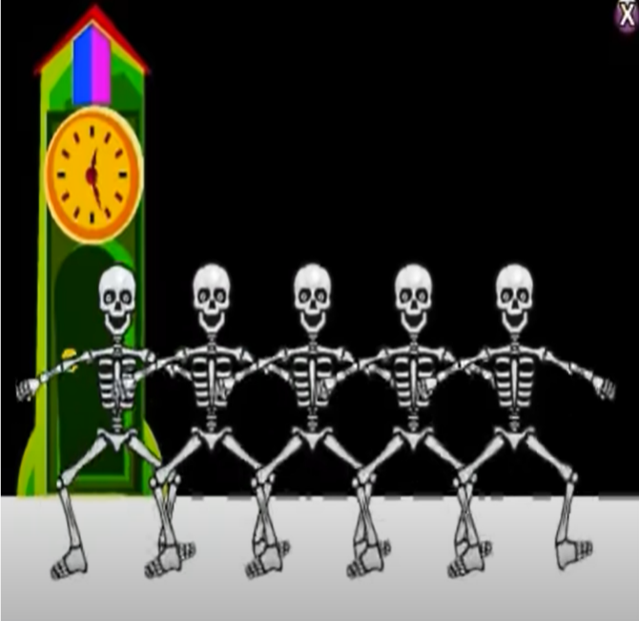

Grammar for the Month

Unnecessary use of ‘so I did’/ ‘so I do’

I saw the dog, so I did. Incorrect
I saw the dog. √ Correct

I like to play football, so I do Incorrect I like to play football √ Correct

Irish for the Month
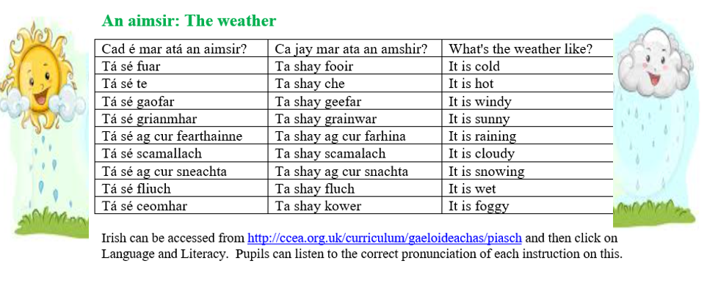

Dates for Term One  Thursdays Ongoing Swimming for the P7 class  Wednesdays Once a month Adoration for P4-7  Thursdays Ongoing Library visits  Tuesday 17 October P3 to visit Carrickfergus Castle  Mon -Thurs 23-26 October Parent / teacher meetings  Friday 27 October P5 Assembly  Monday -Friday 30 October – 3 November incl. Hallowe’en holidays  Thursday 21 December School closes at 12 noon  Thursday 4 January School reopens.  TOPICS  The children enjoy learning all about the world around them. In learning through their topics children are able to apply their learning and develop cross-curricular skills. |  | During/Afterschool Clubs  Mondays 5 Sept – 4 Nov Choir P5 – P7 with Mrs Bradley & Mrs McGill  Thursdays Starting 14 Sept Gaelic with Andrena  Thursdays 2-2.45pm 21 Sept – 26 Oct Foundation Fun Club for P1 & P2 Children should be picked up from the Tirkeeran site at 3pm unless travelling to Appletree’s in the school bus  Wednesdays 8 – 22 Nov Cookery Club with Miss Conway for P3 (Max 10)  Wednesdays 29 – 13 Dec Second group Cookery Club for P3 (Max 10)  Thursdays 21 Sept – 26 Oct Gaelic with Mr McCann for P4 & P5 boys  Thursdays 9 Nov – 14 Dec Handball for P6 pupils with Mrs Ball  Thursdays 9 Nov – 14 Dec Camogie with Mr McCann for P4 & P5 girls  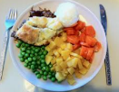  School Dinners and Free School Meals  School dinners cost £2.60 per day, please send in an envelope. Please make cheques payable to the Education Authority.  The number of pupils who are on the free school meals’ register affects the school budget. If you are in any doubt as to whether you are entitled to free dinners please complete a Free School Meals’ form which is available via the EA’s website, https://www.eani.org.uk/financial-help/free-school-meals-uniform-grants, even if you do not wish your child to actually take dinner.  Child Protection and Safeguarding.  Children are encouraged to share any worries with their parents, and in school with any adult. The school will remind children regularly that Mrs Ball (Designated Teacher for Child Protection), Mrs McCloy and Mrs Heron (Deputy Designated Teachers) are always available to handle any concerns.  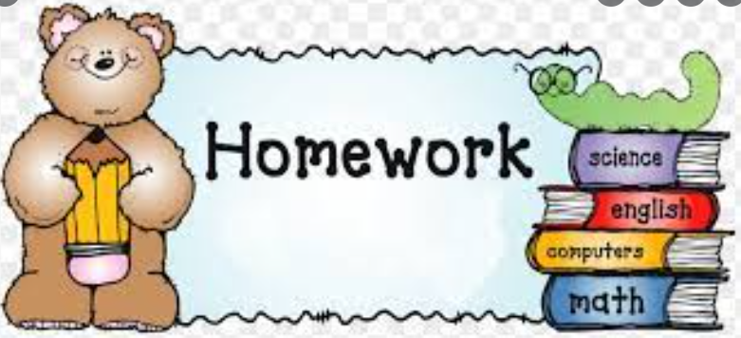  We understand that on occasion it is virtually impossible and impracticable for your child to complete their homework. When this is the case simply send the teacher a dojo stating that, ‘It is impractical for Sean to complete his homework tonight.’  No further explanation is necessary. It is optional if you the parent wants the child to complete the homework on a different night  Allergies / Medical Needs  As you are aware a number of children within the school are allergic to nuts and or eggs. As an anaphylactic reaction to these foods can be potentially life threatening we ask that all parents ensure that no nut products (e.g. Kinder eggs/ bars) or egg (such as egg sandwiches) be brought into the school.  Administering Medication  If your child has a medical condition and required medication, please ensure the medication is in date.  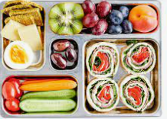  Boomerang Lunches  To encourage recycling and in order that parents can gauge what children have eaten for their lunch and break the school has a boomerang lunch policy. This means that all packaging or uneaten lunch will return home in the pupils’ lunchboxes
Primary 1 – All About Me
Primary 2 – Wow Wee, Look at Me!
Primary 3 – Castles & Knights
Primary 4 – Mighty Me
Primary 5 – Where We Live
Primary 6 – Famine
Prmary 7 – Rainforest

Library Visits
Each class will have the opportunity to visit Garvagh library between now and Christmas. This is a great support and enhances the excellent provision for reading in the school.

Collection of Children from EA Bus
It is important to note that, according to the EA Transport policy, our school bus driver cannot let children off the bus unless a responsible adult is there to collect them.

Mathletics
Mathletics is an excellent fun maths learning programme. Pupils thrive on the competitive element of obtaining points by competing against other pupils online or by completing tasks independently. Pupils are given appropriately levelled activities which are in line with the Northern Ireland Curriculum. ‘Mathletics’ will be used both in school and at home.

The cost per pupil is £5 (approximately 10p for 52 weeks / 25p if only used for 20 weeks) with a maximum payable of £15 per family. Parents who subscribe will ensure their child has access to unlimited tutorials for 52 weeks.

We would urge all parents, regardless of the age or ability of your child to support this initiative as we believe that it is a relatively inexpensive way of significantly improving your child’s mathematical results.

New Mathletics Certificate System
Mathletics have recently updated their certificate system. There are now 8 certificate levels with 5 ranks within each certificate. This means that there are now 40 certificates in total that students can earn each academic year.
A certificate is earned by achieving 1000 points (or more) in a week. The Mathletics week starts from Monday morning and runs until midnight on Sunday evening.
The new certificate types are as follows:
-Bronze, Silver, Gold, Platinum,
-Emerald, Diamond, Epic and Legend
As a reward for their efforts and hard work, pupils will visit the shop when they achieve their 5th Platinum certificate and again when they achieve their 5th Legend certificate.
Certificates will now be reset each year, so that every year students have a chance of being able to achieve Legend status. We hope this will encourage pupils to engage with Mathletics regularly to ensure they are on track to earn the highest rewards possible.

